**Enterprise Resource Planning**

**Training User Manual**

**VERSION 12.0.0**

**Management**

# Management (Reports)

**Options**

1. [Sales Dash Board](http://192.168.1.17:8080/zab/login?screen=opdashboard&option=Sales+Dash+Board&menuname=misreports)
   1. Sales Report by Sales Person For Current Month / Previous month

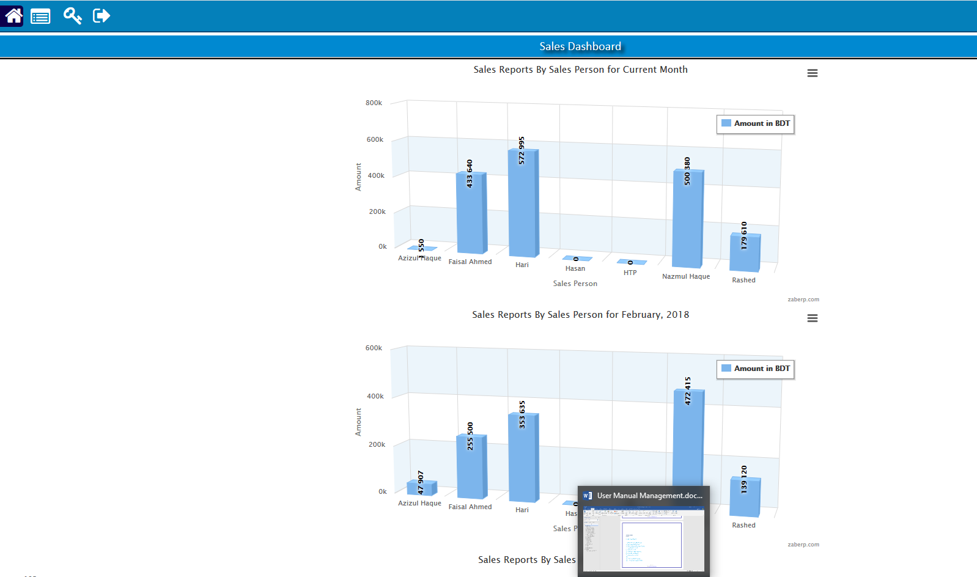

* 1. Sales Report by Sales Person For last 90 days

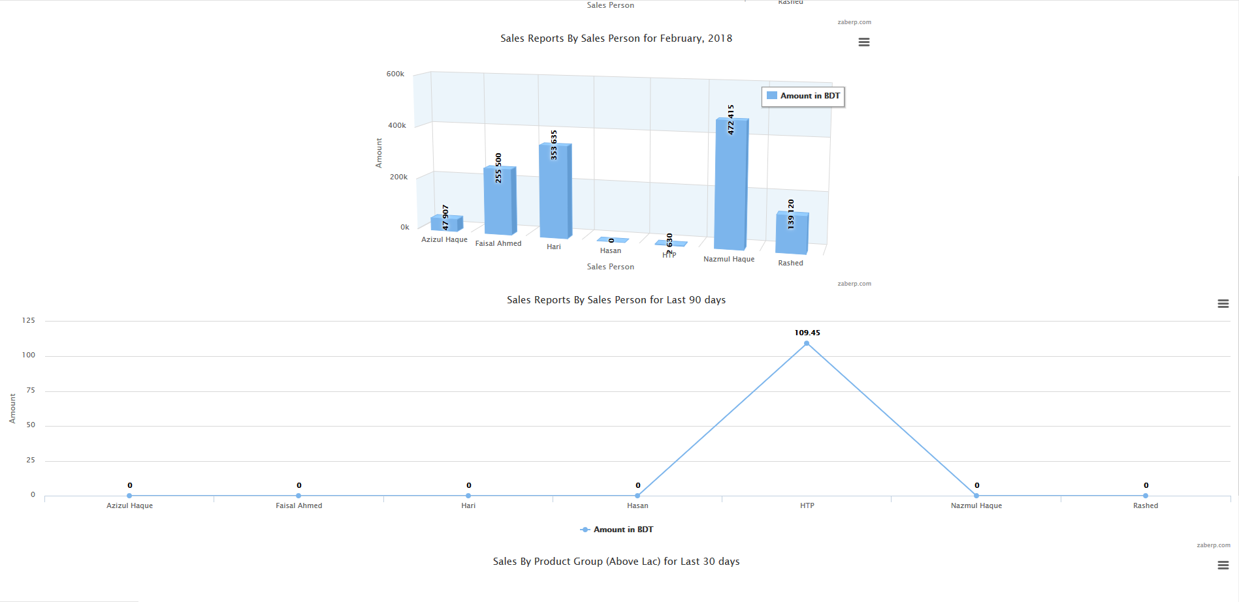

1. [Date Wise Sales (Summary)](http://192.168.1.17:8080/zab/login?screen=*viewcrystal+opsalessumdate%284%3Bin%2Cdt%2Cdt%2Cst%3Bzid%2Cfdate%2Ctdate%2Cfcus%3Bxdate%3DFrom+Date%3D%23date%2Cxdate%3DTo+Date%3D%23date%2Cxcus%3DCustomer%2Cxviewtype%3DReport+View%29&option=Date+Wise+Sales+%28Summary%29&menuname=misreports)
2. [Sales Summary By Item](http://192.168.1.17:8080/zab/login?screen=*viewcrystal+opsalessumitem%284%3Bin%2Cdt%2Cdt%2Cst%3Bzid%2Cfdate%2Ctdate%2Cfitem%3Bxdate%3DFrom+Date%3D%23date%2Cxdate%3DTo+Date%3D%23date%2Cxitem%3DItem%2Cxviewtype%3DReport+View%29&option=Sales+Summary+By+Item&menuname=misreports)
3. [Profit (Summary) by Sales Person](http://192.168.1.17:8080/zab/login?screen=*viewcrystal+opsalesusersumpfsp%284%3Bin%2Cst%2Cst%2Cst%3B%40zid%2C%40fsdate%2C%40tsdate%2C%40pers%3Bxdate%3DFrom+Date%3D%23date%2Cxdate%3DTo+Date%3D%23date%2Cxperson%3DSales+Person%2Cxviewtype%3DReport+View%29&option=Profit+%28Summary%29+by+Sales+Person&menuname=misreports)
4. [Supplier Wise Stock](http://192.168.1.17:8080/zab/login?screen=*viewcrystal+imsupwisestock%286%3Bin%2Cdt%2Cst%2Cst%2Cst%2Cst%3Bzid%2Cdate%2Csup%2Cgroup%2Cbrand%2Citem%3Bxdate%3DTo+Date%3D%23date%2Cxsup%3DSupplier%2Cxgritem%3DGroup%2Cxbrand%3DBrand%2Cxitem%3DItemt%2Cxviewtype%3DReport+View%29&option=Supplier+Wise+Stock&menuname=misreports)
5. [Item Wise Stock](http://192.168.1.17:8080/zab/login?screen=*viewcrystal+opstockstmt%284%3Bin%2Cdt%2Cdt%2Cst%3Bzid%2Cfdate%2Ctdate%2Cxitem%3Bxdate%3DFrom+Date%3D%23date%2Cxdate%3DTo+Date%3D%23date%2Cxitem%3DItem%2Cxviewtype%3DReport+View%29&option=Item+Wise+Stock&menuname=misreports)
6. [Combine Ledger Summary](http://192.168.1.17:8080/zab/login?screen=*viewcrystal+combineledsum%284%3Bin%2Cst%2Cdt%2Cdt%3Bzid%2Ccus%2Cfdate%2Ctdate%3Bxcus%3DParty%3D%2Cxdate%3DFrom+Date%3D%23date%2Cxdate%3DTo+Date%3D%23date%2Cxviewtype%3DReport+View%29&option=Combine+Ledger+Summary&menuname=misreports)
7. [Profit & Loses Detail](http://192.168.1.17:8080/zab/login?screen=*viewcrystal+acpldetail%284%3Bin%2Cin%2Cdt%2Cdt%3B%40zid%2C%40year%2C%40fdate%2C%40tdate%3Bxyearcombo%3DYear%2Cxdate%3DFrom+Date%3D%23date%2Cxdate%3DTo+Date%3D%23date%2Cxviewtype%3DReport+View%29&option=Profit+%26+Loses+Detail&menuname=misreports)
8. [Balance Sheet Detail](http://192.168.1.17:8080/zab/login?screen=*viewcrystal+acbalancesheetdatedetailprime%284%3Bin%2Cdt%2Cdt%2Cin%3Bzid%2Cfdate%2Ctdate%2Cyear%3Bxdate%3DFrom+Date%3D%23date%2Cxdate%3DTo+Date%3D%23date%2Cxyear%3DYear%2Cxviewtype%3DReport+View%29&option=Balance+Sheet+Detail&menuname=misreports)
9. [Outstanding Summary](http://192.168.1.17:8080/zab/login?screen=*viewcrystal+comoutsum%282%3Bin%2Cst%3Bzid%2Ccus%3Bxcus%3DParty%3D%2Cxviewtype%3DReport+View%29&option=Outstanding+Summary&menuname=misreports)
10. [Summary Supplier Ledger](http://192.168.1.17:8080/zab/login?screen=*viewcrystal+apledsummary%284%3Bin%2Cst%2Cdt%2Cdt%3Bzid%2Ccus%2Cfdate%2Ctdate%3Bxsup%3DSupplier%3D%2Cxdate%3DFrom+Date%3D%23date%2Cxdate%3DTo+Date%3D%23date%2Cxviewtype%3DReport+View%29&option=Summary+Supplier+Ledger&menuname=misreports)

# Reports

## Printing report to preview data

|  |  |  |  |
| --- | --- | --- | --- |
| **Step 1** |  |  | Open System **>** Sales & Invoice **>** Reports |
| **Step 2** |  |  | Select a report option. |
| **Step 3** |  |  | Select the start date, end date & other fields to specify data previewing in the report. |
| **Step 4** |  |  | Click **“View Report”** to preview in print format. |
| **Result** |  |  | The report is previewed in print format. |

